Nature and Purpose of Internal Assessment
Internal assessment is an integral, and compulsory, part of both the SL and HL course of study in economics and accounts for 20% of the final mark.
The internal assessment component, as well as being interesting and productive, forms an important part of the assessment of the economics course. It is essential that the teacher provides appropriate guidance to students. Students must also be given a copy of the internal assessment details and the assessment criteria. These can be found in the Economics guide (November 2010).

Internal assessment in IB economics
Internal assessment enables students to apply their knowledge of economic theory to real-world situations without the time constraints of written examinations. The production of a portfolio of three commentaries based on extracts from published news media has a number of further advantages.

The portfolio:
- allows students to follow contemporary issues

- allows students to explore theories in more detail

- enables students to follow up aspects of economics in which they are particularly interested. It enables them either to focus on international issues to broaden their understanding of the global impact of economics, or to focus on issues particularly relevant to their own country or region

- can be used as a motivating factor, increasing the liveliness and relevance of classroom sessions. Because it does not add any content to the syllabus, it can be a natural part of classroom and homework activities
is a way of rewarding student enthusiasm and achievements during the learning process.

Internal Assessment: Overview
Portfolio—SL and HL
Internal assessment in economics enables students to demonstrate the application of their knowledge and understanding of economic theory to real-world situations. They do this through the preparation and completion of a portfolio.

- 20 hours of class time
- Article identified and commentary written individually
- Portfolio of three commentaries
- 750 words (maximum) for each commentary
- Marked by the teacher
- Externally moderated
- 20% of total marks at SL and at HL

Preparation and completion of internal assessment
The following diagram illustrates the stages in the process.

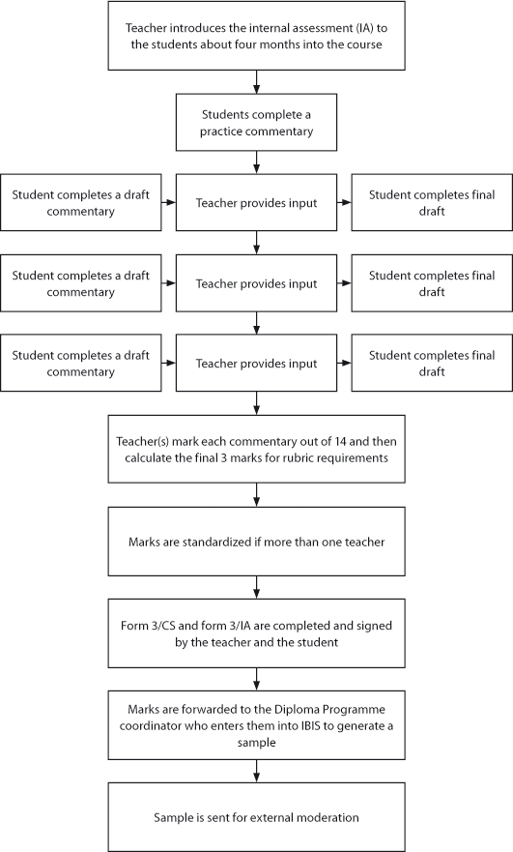

Requirements
Economics students at SL and HL produce a portfolio of three commentaries based on articles from published news media. Each article must be based on a different section of the syllabus.
- Microeconomics
- Macroeconomics
- International economics
- Development economics

Rubric requirements
The following requirements are necessary for the production of the commentaries. If these requirements are not met students will lose marks under criterion F: rubric requirements.
1. Word limit
Students must produce a portfolio of three commentaries. Each commentary must not exceed 750 words.
Note: Moderators will not read beyond 750 words for each commentary.
The following are not included in the word count.
- Acknowledgments
- Contents page
- Diagrams
- Labels—of 5 words or fewer
- Headings on diagrams—of 10 words or fewer
- Tables of statistical data
- Equations, formulae and calculations
- Citations (which, if used, must be in the body of the commentary)
- References (which, if used, must be in the footnotes/endnotes)

Please note that footnotes/endnotes may be used for references only. Definitions of economic terms and quotations, if used, must be in the body of the work and are included in the word count. Please note that a citation is a shorthand method of making a reference in the body of the commentary, which is then linked to the full reference in the footnotes/endnotes.

2. Articles
Each article must be based on a different section of the syllabus.
3. Sources
Students must use a different source for each commentary.

4. Contemporary articles
Students need to look for articles relating to current events and these must be published no earlier than one year before the writing of the commentary.

5. Contents
Each portfolio must contain:
- a summary portfolio coversheet
- a commentary coversheet for each commentary
- three commentaries, accompanied in each case by the relevant article.

How to choose an extract
The nature of articles
The choice of an appropriate article is the most crucial aspect of writing a successful commentary. The article used does not have to be purely economic, as the application of economic theories and concepts can be observed in many areas. Articles without any obvious economics are sometimes the most effective, allowing students to introduce economic analysis where it is not immediately apparent.
Articles that include substantial economic analysis, such as in The Economist, while allowable as a source, may leave little opportunity for further analysis.

Suitable articles
Articles must be chosen from the news media: newspapers, magazines or the internet. Students need to look for articles relating to current events, and these must be published no earlier than one year before the writing of the commentary.
The World Wide Web is a good source of articles. However, news media websites are the only appropriate sources. The use of blogs is not allowed for internal assessment unless these are associated with recognized news organizations. Students must take care to record correctly the actual date the article was published, not just when it was posted on the internet.
Graphic sources (for example, pictures, cartoons and advertisements) are not to be used as source articles: these do not qualify as articles for the purpose of this internal assessment.
Students must take care not to choose articles where there is little room for their own analysis and evaluation.

Time period of articles
It is helpful to encourage students to collect articles for their commentaries throughout the course. However, commentaries must be written within a year of the published date of the article.

Length of articles
Shorter articles are often a good choice as they tend to be focused on just one or two economic theories/concepts. A rough guide is approximately one full side of A4/letter-size paper (in font 10–12 with normal line spacing) and no longer than two sides of A4/letter-size paper. It is important to note that moderators (external examiners) will not read beyond two sides of text.
Articles that are too short will not usually provide enough interesting issues for students to analyze.
If students wish to use a long article, they must include the original article in its entirety, with the selected part(s) highlighted. This helps students to stay focused. Students must remember that the teacher and moderator will only read the highlighted section(s) and it is crucial, therefore, to highlight all the relevant sections in the commentary.

Language of articles
In most cases the article chosen will be in the same language as the commentary. If an article in another language is used, the student must provide an accurate translation of the whole article. Students must also include the original article in their portfolio.
If students wish to use a long article, the selected part(s) must be highlighted, both on the translation and the original. (See “Length of articles”.)

Individual work on the articles and commentaries
Students must select their own articles to analyse. The teacher must not give the articles to the class or even a single extract to a group of students. It can happen that students select the same articles by chance. This is acceptable, provided the teacher is confident that each of the students involved came up with the article independently. However, the teacher may require students to find alternative articles.
The production of the commentary must also be each student’s individual work and must not be prepared collaboratively with any other members of the class. Commentaries must not be based on any articles used for class activities.
For fuller information see “Responsibilities of the teacher” and “Responsibilities of the student” in this support material.

Managing the process
Time allocation
It is important that the teacher prepares the students for the internal assessment requirements in good time to meet the school’s internal deadlines in preparation for the external deadline.
Teachers can start the process once they consider that students have enough knowledge of economics to adequately address the articles. Experience suggests that the best time to introduce the internal assessment component to students is approximately halfway through the first year of a two-year course.
The three commentaries should be written over a period of about one calendar year, so that much of the syllabus is known to students and they are not restricted in the choice of economic theories/concepts to address in their commentaries.
The school should set its own internal deadlines and the students must be made aware of these.
When planning courses and deadlines, economics teachers should endeavour to coordinate deadlines with teachers of other Diploma Programme subjects and with the Diploma Programme coordinator.

Practice commentaries
Before students commence work on their own portfolios, it is strongly recommended that teachers introduce the process by using a practice article requiring the students to produce a practice commentary as a piece of formative assessment. Students may write one (or more) practice commentaries before writing the required three commentaries at regular intervals throughout the rest of the course.
It is not in the best interests of students to write large numbers of commentaries as this may detract from their other course activities.

Integration into classroom activities
Internal assessment work should be included in normal classroom activities.
Some suggested activities include:
- presenting and discussing the nature of the internal assessment and the assessment criteria
- giving advice on suitable media resources to use
- encouraging students to bring into class articles they think are suitable sources discussing the way to write a commentary—focusing on strategies for writing commentaries and giving particular attention to evaluation.

Responsibilities of the student
It is the responsibility of the student to:
- choose the articles used for the three commentaries independently
- observe the regulations relating to internal assessment
- meet deadlines
- acknowledge all sources of information and ideas using a recognized academic format
- include a coversheet for each commentary and for the whole portfolio.
It is strongly recommended that students:
- start work early
- pay careful attention to the assessment criteria
- consult news media sources regularly
- check and proofread the final version of each commentary carefully
use the “Checklist for students” (available in this publication) to make sure that all rubric requirements are met.

Academic honesty and referencing
It is the responsibility of teachers to ensure that all students understand the basic meaning and significance of concepts that relate to academic honesty, especially authenticity and intellectual property. Teachers must ensure that all student work for assessment is prepared according to the requirements and must explain clearly to students that internally assessed work must be entirely their own.
The following information does not require referencing:
- information and analysis based on standard economic theory
- quotations from the article upon which the commentary is based (see below).
Anything that does not fall into the above categories must be cited consistently by the student using the recognized academic reference system.
Students may use quotations from the articles but students must be careful not to include too many quotations, leaving little room for their own analysis. Quotations from the article do not need to be referenced, although these must be identified clearly by using inverted commas and by, for example, giving a line or paragraph number.
References from the internet must be cited fully, including the full web address and the date the site was accessed.
Sometimes students use sources that are from a news agency, for example, Thomson Reuters or Associated Press, and these appear in another publication. Students must cite the final publication, not the news agency, as the source.

Internal assessment criteria – SL and HL

The internal assessment requirements are the same for both SL and HL students.
Students produce three commentaries, based on published extracts from the news media. The extracts may be from a newspaper, a journal or the internet, but must not be from television or radio broadcasts. Each article must be based on a different section of the syllabus (microeconomics, macroeconomics, international economics and development economics).

Overview
There are five internal assessment criteria for each commentary.
Criterion A | Diagrams | 3 marks
Criterion B | Terminology | 2 marks
Criterion C | Application | 2 marks
Criterion D | Analysis | 3 marks
Criterion E | Evaluation | 4 marks
 | Total | 14 marks
There is one internal assessment criterion for the whole portfolio.
Criterion F | Rubric requirements | 3 marks
Each commentary is assessed individually for the first five assessment criteria (criteria A–E) and then criterion F is applied to the whole portfolio.
The maximum for the portfolio is 45 marks: (14 marks x 3 commentaries) + 3 marks = 42 + 3 marks.
The assessment criteria are related to the assessment objectives.
- Criterion A: A02 and AO4
- Criterion B: AO1
- Criterion C: AO2
- Criterion D: AO2
- Criterion E: AO3
- Criterion F: AO4

Portfolio—SL and HL
Criterion A: Diagrams
- This criterion assesses the extent to which the student is able to construct and use diagrams.
Level | Descriptor
0 | The work does not reach a standard described by the descriptors below.
1 | Relevant diagrams are included but not explained, or the explanations are incorrect.
2 | Relevant, accurate and correctly labeled diagrams are included, with a limited explanation.
3 | Relevant, accurate and correctly labeled diagrams are included, with a full explanation.

Criterion B: Terminology
- This criterion assesses the extent to which the student uses appropriate economic terminology.
Level | Descriptor
0 | The work does not reach a standard described by the descriptors below.
1 | Terminology relevant to the article is included in the commentary.
2 | Terminology relevant to the article is used appropriately throughout the commentary.

Criterion C: Application
- This criterion assesses the extent to which the student recognizes, understands and applies economic information in the context of the article.
Level | Descriptor
0 | The work does not reach a standard described by the descriptors below.
1 | Relevant economic concepts and/or theories are applied to the article.
2 | Relevant economic concepts and/or theories are applied to the article appropriately  throughout the commentary.

Criterion D: Analysis
- This criterion assesses the extent to which the student can explain and develop appropriate economic theories and/or concepts in the context of the article.
Level | Descriptor
0 | The work does not reach a standard described by the descriptors below.
1 | There is limited economic analysis relating to the article.
2 | There is appropriate economic analysis relating to the article.
3 | There is effective economic analysis relating to the article.
Criterion E: Evaluation
- This criterion assesses the extent to which the student synthesizes his or her analysis in order to make judgments that are supported by reasoned arguments.
Level | Descriptor
0 | The work does not reach a standard described by the descriptors below.
1 | Judgments are made that are unsupported, or supported, by incorrect reasoning.
2 | Judgments are made that are supported by limited reasoning.
3 | Judgments are made that are supported by appropriate reasoning.
4 | Judgments are made that are supported by effective and balanced reasoning.
Criterion F: Rubric requirements
- This criterion assesses the extent to which the student meets the five rubric requirements for the complete portfolio.
  - Each commentary does not exceed 750 words.
  - Each article is based on a different section of the syllabus.
  - Each article is taken from a different and appropriate source.
  - Each article was published no earlier than one year before the writing of the commentary.
  - The summary portfolio coversheet, three commentary coversheets and the article for each commentary are included.
Level | Descriptor
0 | The work does not reach a standard described by the descriptors below.
1 | Three rubric requirements are met.
2 | Four rubric requirements are met.
3 | All five rubric requirements are met.

